- Purpose
  - The purpose of this document is to describe the procedure for assembling the Lower Frame on the Genesys 20 with Pad Assist.
- Scope
  - This SOP applies to all equipment assembly team members. The process applies to the following machine ID’s:
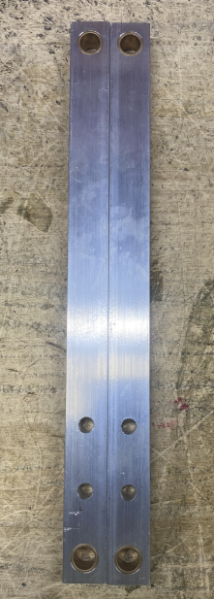
EP50206EQS0600BE1200 – Frame G20 PA
- Responsibilities
  - The operations manager/supervisor is responsible for enforcing this SOP.
- Materials
  - The proper materials needed for this process are listed on the machine work order.
- Definitions

- Procedure
  - Take 2 head lift arms (E28863) and press a sleeve bearing (E28685) into the hole on each end.

  - Place a frame weldment (E28878) upside down on the table.

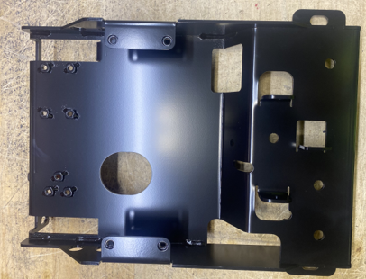
  - Assemble part of the foot pedal assembly. Take a foot pedal tension arm (E28868) and attach it to a head lift arm and a lift arm brace (E28864) in the orientation shown. Use 2 flat head screws (E28984) to do this. It is best to tap out the holes on the lift arm brace prior to trying to run a screw through them.

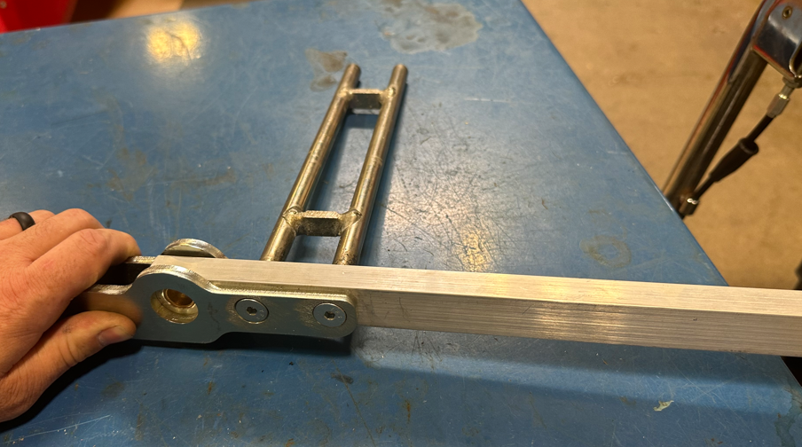
E28868
E28863
E28864

  - Take a foot pedal linkage arm (E28869) and install one end of an extension spring (E28883) into both it and the foot pedal tension arm as shown. Orient the two arms to each other as shown.

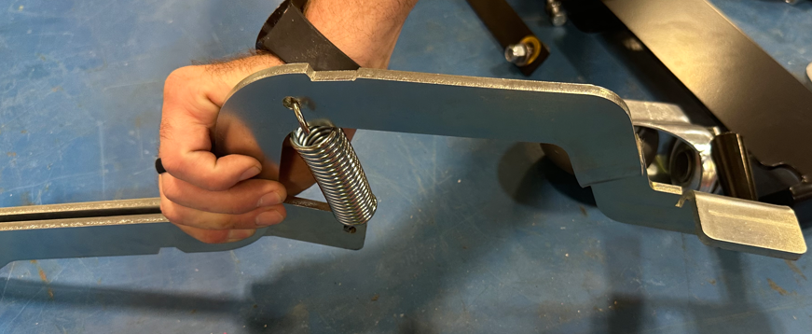
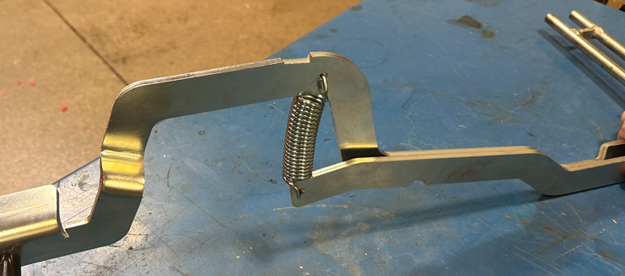
  - Hold the foot pedal assembly firmly as the two arms will try to move out of position since they are not fastened together at this point. Feed the foot pedal assembly through the frame as shown.
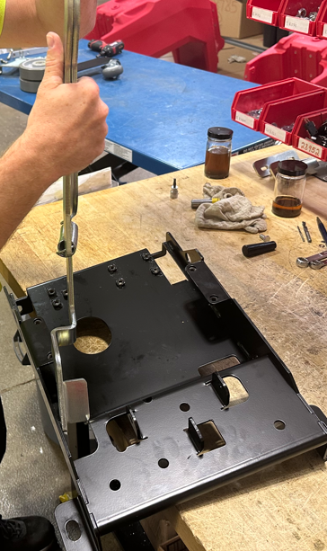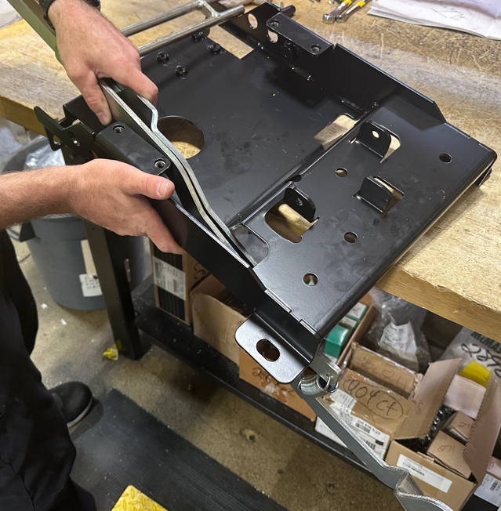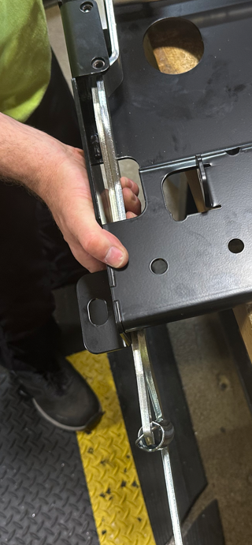
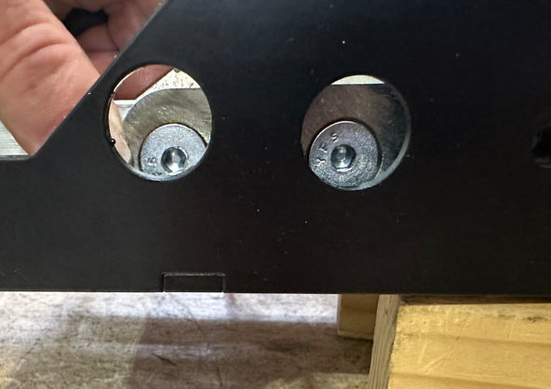
Line flat heads up with holes in frame

  - Place a sleeve bushing (E28684) into the bronze bushing in the lift arm.

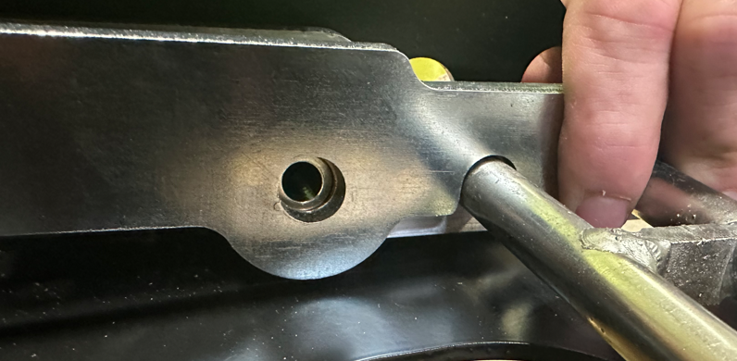
  - Fasten the foot pedal assembly to the frame with a bolt (E28982), 2 washers (E28622), and a nylock nut (E28624). One washer goes on the outside of the frame and one goes on the inside.

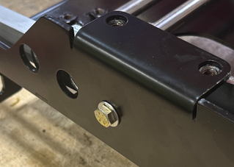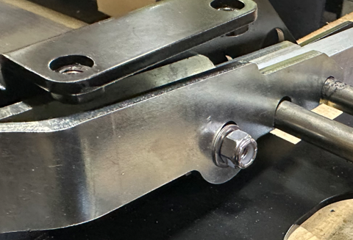

  - Take the 2nd lift arm and place a sleeve bushing (E28684) into it on the end shown.

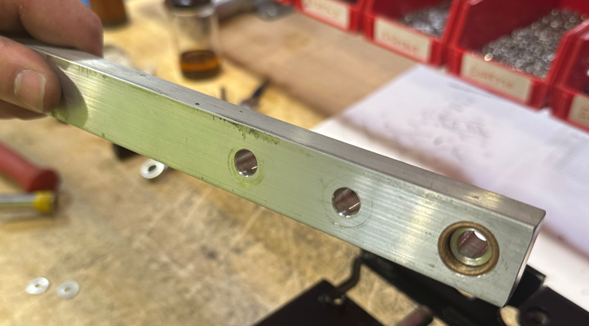

  - Position on the far end of frame as shown. Attach the arm to the frame using a bolt (E28982), 2 washers (E28622), and a nylock nut (E28624). Only tighten it to finger tight at this point.

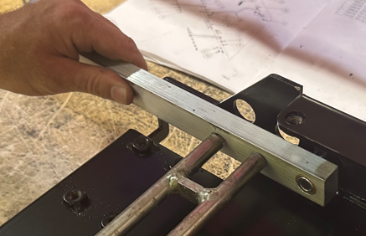
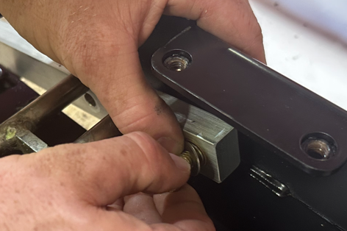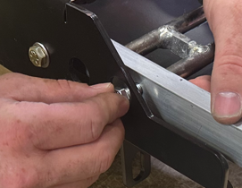

  - Attach the lift arm to the brace using 2 bolts (E10112) and 2 washers (E28622). Once these are tight, go back and tighten the bolt and nut from the previous step.

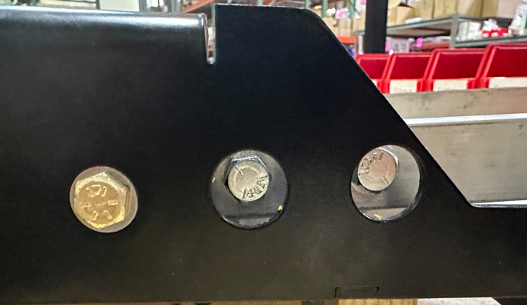
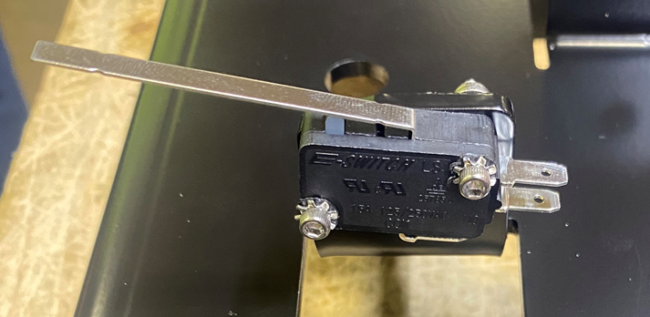
  - Attach a microswitch (E28952) to the location shown. Use 2 screws (E28769) with toothed washers (E28821) under the heads. Use a flat washer (E29368) with a nylock nut (E28770) on the other side. Ensure switch is pushed up completely before tightening.

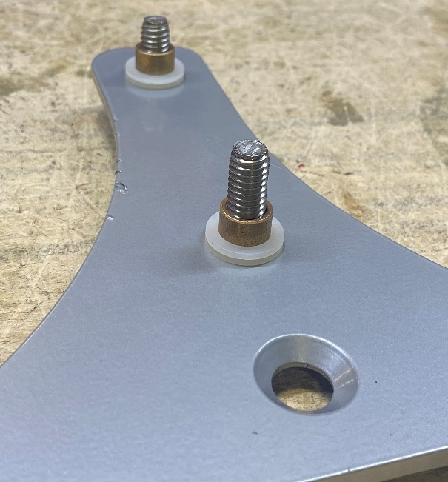
  - Take a squeegee swing plate (28880) ensure the countersink hole is facing up. Place a hex bolt (E29436) with a flat washer (E29438) though the bottom of the two holes of the swing plate. Then place 2 plastic washers (E28937) and a sleeve bearing (E28936) over each of the two bolts. Ensure both plastic washers are over the sleeve bearing and won’t get pinched.
Countersink Hole

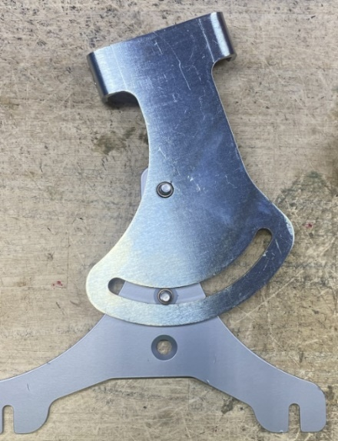
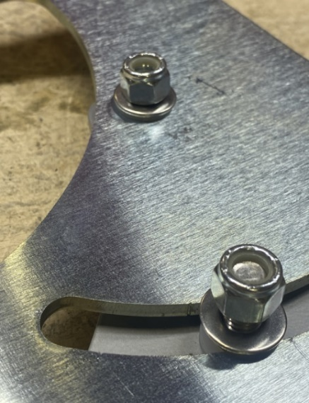
  - Place a squeegee lift bracket (E28879) over the swing plate. Line up the hole and fasten each bolt with a plastic washer (E28937), flat washer (E29438), and a nut (E11146) ensuring the brackets pivot freely. Note that the two plastic washers are now between the two plate and facilitate a smooth pivot.

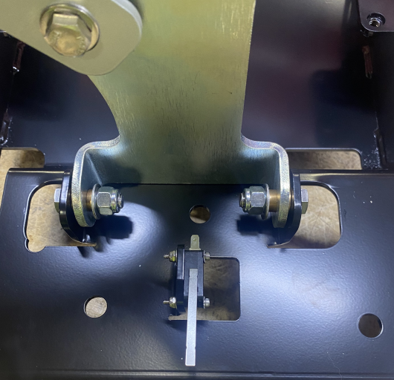
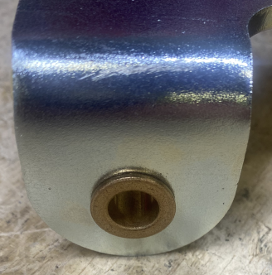
  - Put a flanged sleeve bearing (E28591) through each of the two holes in the pivot bracket. Put the pivot bracket into position on the frame and attach using 2 hex bolts (E29436), 2 washers (E29438) under the nuts, and 2 lock nuts (E11146). If there is extra space between the bracket and frame place a plastic washer (E83145) between the pivot bracket and the frame. Ensure the bracket actuates the switch properly when it pivots.

  - Attach the swivel casters (E29021) to the frame using 2 hex nut (E81088).

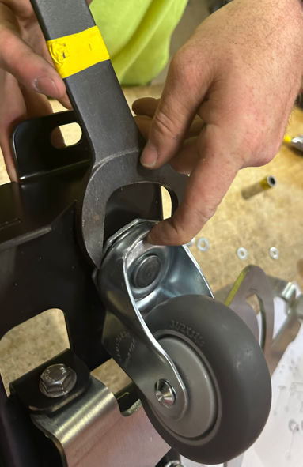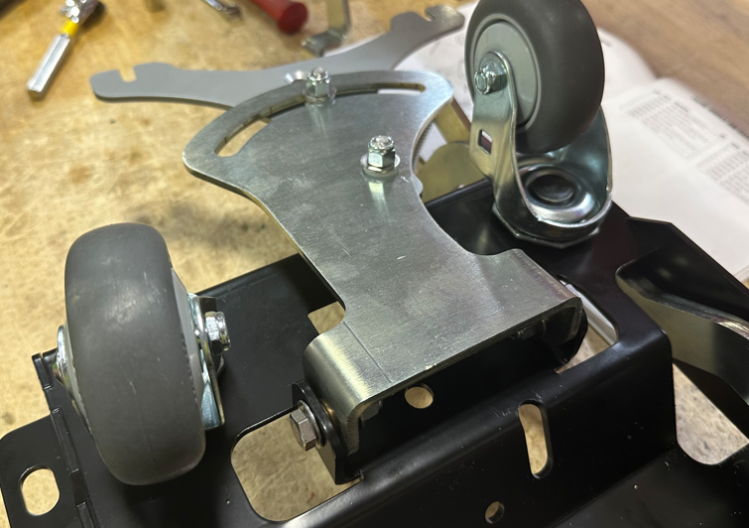

  - Take a wheel bracket (E28988) and attach an idle wheel axle (E28989) onto each side as shown using a nut (E86489) and a washer (E83702).

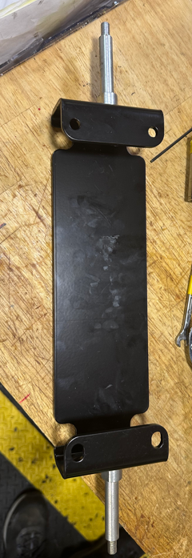
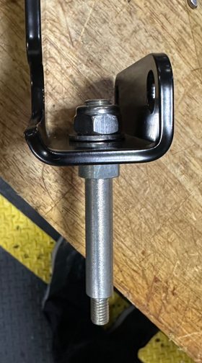

  - Put a wheel (E28987) onto each axle and secure each with a nut (E86853) and a washer (E83404). Tighten the nut until it meets the shoulder on the axle.

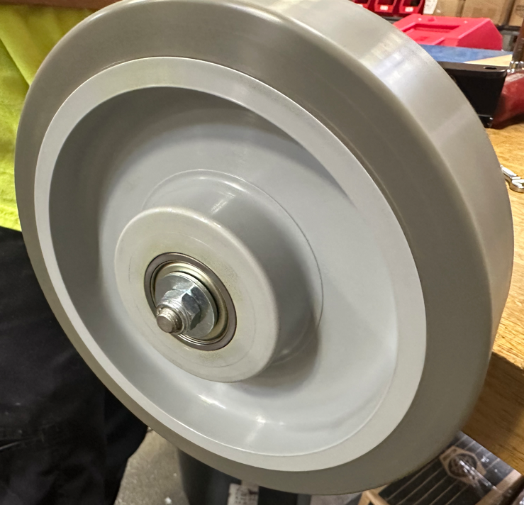

  - Place the wheel bracket onto the frame as shown and attach it using 4 bolts (E81089) and 4 lock washers (81066).
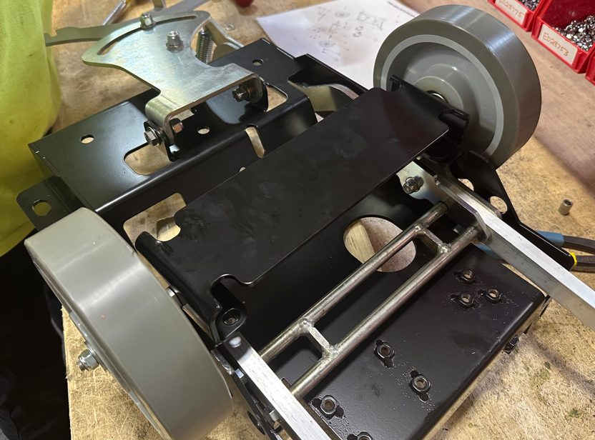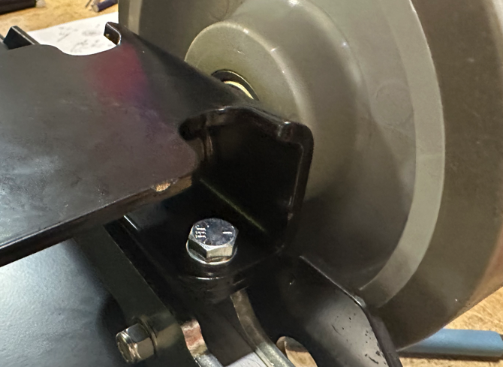

  - Feed a wire harness (E28893) through the frame as shown.
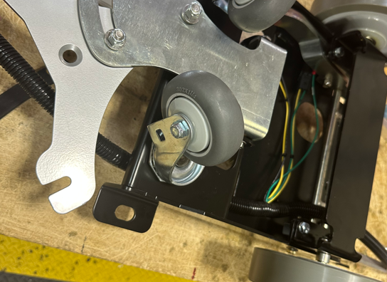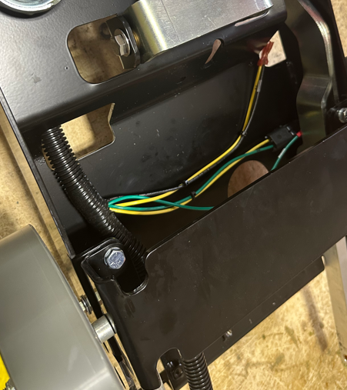
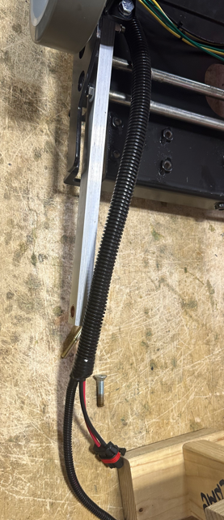
  - Attach the black wire (10U) and yellow wire (14) to the squeegee lift switch on the terminals shown.

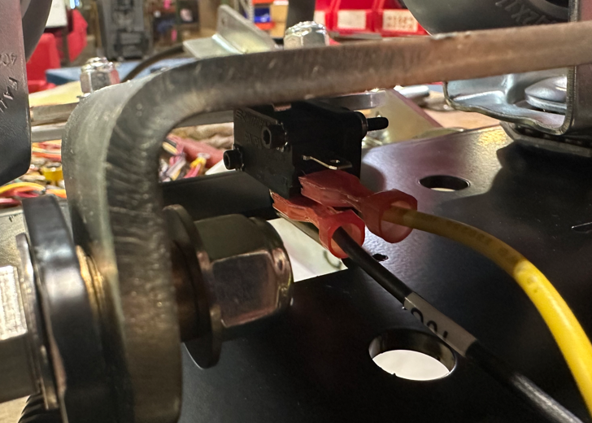

  - Take a bolt (E29436) and place a flat washer (E29438) over it. Next put a static strap (E29459) and the green ground wire (64) over the bolt. Attach the bolt to the frame with a washer (E29438) and a nut (E11146).

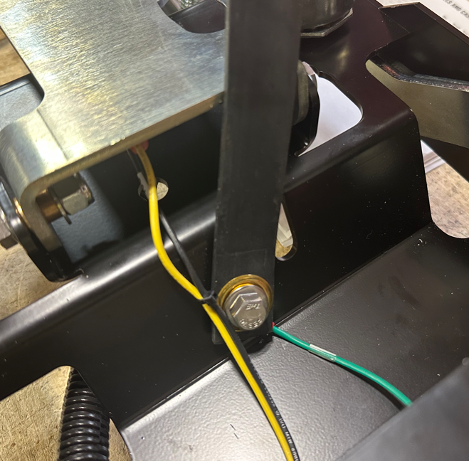
  - Flip the frame assembly over and onto its wheels.

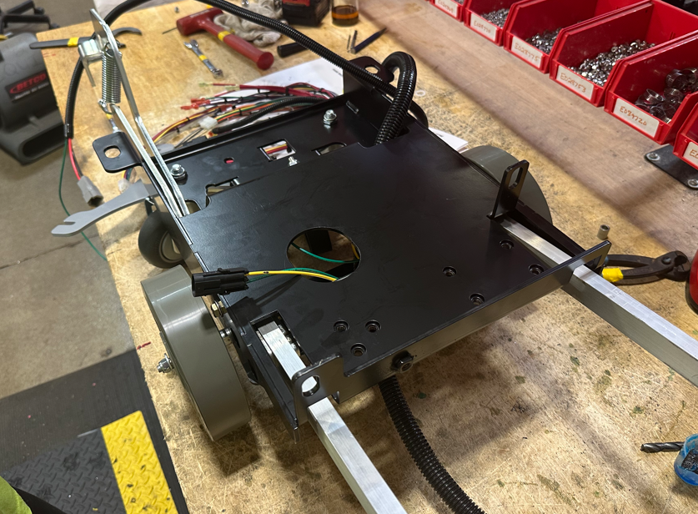

  - Attach the lift handle (E28884) to the end of the foot pedal linkage arm with a bolt (E81089).

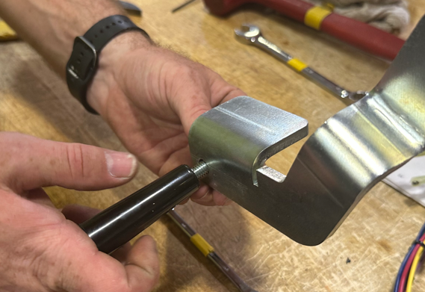

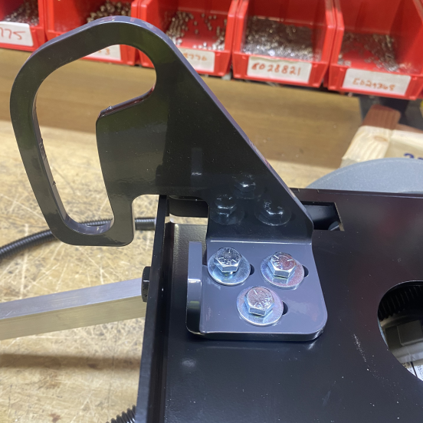
  - Put a head lift guide (E28865) in appropriate location. Feed 3 bolts (E81089) and 3 washers (E81062) through the top. Do not tighten completely, leave loose.

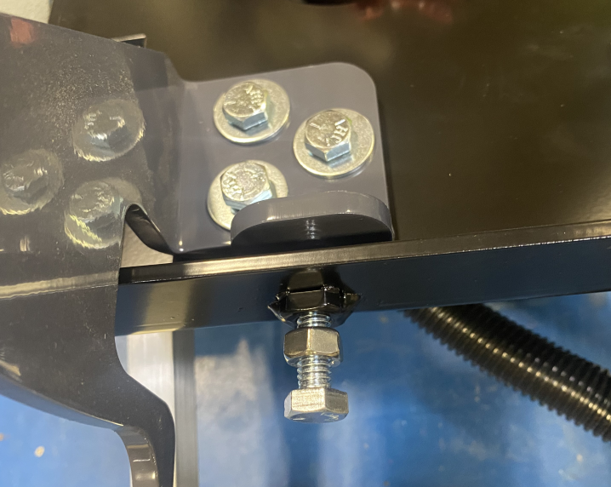
  - Thread nut (E12524) on to bolt (E10112) and screw into the front of the frame.

- References (optional section as needed)

- Training Guide

Functional Training Groups Requiring Training
Equipment Assembly Group

- SOP Change Control

Date of Change | Reason for Change
TBD | This is the first version of the S.O.P. hence there are no revisions to this document.

Approvals

Submitter/Author Approval:__________________________________ Date:______________________

Management Approval:______________________________________ Date:______________________

QAU Approval:_____________________________________________ Date:______________________

